# 7 Three-dimensional finite element simulations

## This section provides some numerical results related to rock deformation in twin tunnels with transverse gallery obtained from the 3D computational model presented in sections 3, 4 and 5. It is emphasized that the primary objective herein is to illustrate the capabilities of the proposed formulation to address within a 3D context the configuration of a complex tunnel structure involving nonlinear and time-dependent couplings. Elaboration of an exhaustive parametric analysis integrating the effects of geometrical, constitutive and loading parameters is notably beyond the scope of the numerical application.

## 7.1 Model data and preliminary considerations

The rock constitutive data used in the subsequent analysis refer to a deep clay from eastern Paris basin (Aisne region, France) studied in [18,20,22,37]. The material properties including elastoplastic and viscoplastic parameters summarized in Table 2 have been evaluated and calibrated from an extensive series of laboratory tests performed under undrained conditions [18,22,37]. The Aisne clay rocks exhibit high density (2.01 to 2.57 g/cm $​^{3}$), a low average water content (between 3 to 11%) and relatively low porosity (typically less than 20%). It is therefore assumed that hydromechanical coupling can be neglected in the analysis of rock material deformation. In particular, the creep tests indicated that the long-term effects primarily stem from material viscosity, with a very low proportion induced by pore pressure redistribution. An important characteristic of the behavior such clay is that irreversible strains are observed in cyclic tests even at small values of axial strain (less than 0.3%). The instantaneous undrained triaxial tests performed at high confining pressure values, such as those prevailing in the rock mass at approximately 450 m deep, indicated that the maximum deviatoric stress remains approximately constant, thus suggesting a Tresca-type failure criterion for the short-term component of the behavior. As for the long-term behavior, the creep tests revealed that the deviatoric stress threshold beyond which the material exhibits creep deformation is almost independent on the mean stress, suggesting that the time-dependent behavior component can be conveniently described by a Tresca-like criterion. Comparison of instantaneous and delayed behaviors reveals that short-term cohesion exceeds long-term cohesion within a ratio ranging between 1.2 and 2. Based on these observations, the constitutive model data adopted for the elastoplastic and viscoplastic components of rock material behavior is summarized in Table 2.

Table 2 also presents the constitutive parameters used for the lining used for the twin tunnels and gallery, the instantaneous relaxation modulus under uniaxial stress at 28 days being referred to as $E_{c_{28}}$. In the analyses that considers elastic behavior of the lining, the concrete elastic modulus is set equal to $E_{c_{28}}$. When viscoelastic behavior is adopted for the lining, the relaxation modulus evolves in time according to the Generalized Kelvin model described in section 4, whereas the Poisson ratio is assumed to be constant within the time interval of analysis. During the tunnel construction process, loading and creep of each lining segment starts from the moment it is activated with properties at age $t_{0}=1$ day, whereas shrinkage effects are assumed to take part at the age of $t_{s}=7$ days.

Table 2 Constitutive parameters used in the numerical analyses.

| PARAMETERS | SYMBOL | UNIT | VALUES |
| --- | --- | --- | --- |
| Constitutive model of rock mass | | | |
| Young’s modulus | $$E$$ | MPa | $$1500$$ |
| Poisson’s ratio | $$ν$$ | - | $$0.49$$ |
| Plastic cohesion | $$c$$ | MPa | 4 $\sqrt{3}/2$ |
| Plastic friction angle | $$ϕ$$ | $$​^{∘}$$ | 0 |
| Viscoplastic cohesion | $$c_{vp}$$ | MPa | 2 $\sqrt{3}/2$ |
| Viscoplastic friction angle | $$ϕ_{vp}$$ | $$​^{∘}$$ | 0 |
| Power law parameter | $$n$$ | - | 1 |
| Reference parameter | $$f_{0}$$ | MPa | 1 |
| Viscosity coefficient | $$η$$ | day | $$40000$$ |
| Constitutive model of lining | | | |
| Characteristic compressive strength at age of 28 days | $$f_{ck}$$ | MPa | $$20$$ |
| Modulus of elasticity at the age of 28 days | $$E_{c_{28}}$$ | MPa | $$30303$$ |
| Poisson’s ratio | $$ν_{c}$$ | - | $$0.2$$ |
| Coefficient defining instantaneous relaxation modulus [27] | $$s$$ | - | $$0.2$$ |
| Relative humidity of ambient environment | $$RH$$ | % | $$70$$ |
| Notional size of member - longitudinal concrete lining | $$h_{t}$$ | cm | $$0.2111$$ |
| Notional size of member - gallery concrete lining | $$h_{g}$$ | cm | $$0.2176$$ |
| Age of concrete at the beginning of shrinkage | $$t_{s}$$ | days | $$7$$ |
| Shrinkage coefficient depending on cement type [27] | $$β_{sc}$$ | - | $$8$$ |
| Temperature | $$T$$ | $​^{∘}$ C | $$20$$ |
| Age of concrete at loading | $$t_{0}$$ | days | $$1$$ |

The parameters defining the structure geometry as well as the excavation and lining installation process are provided in Table 1. All the length parameters are normalized by the tunnel radius $R_{t}$, which amounts to formally consider radius $R_{t}=1$ m in the numerical simulations. As mentioned in Table 1, three different values shall be considered in the simulations for the distance between twin tunnels axes, namely $d_{1}=4R_{t}$, $d_{1}=8R_{t}$, and $d_{1}=16R_{t}$. In addition, constant values of tunnel and gallery advancement rates are considered and fixed to is fixed to . As regards the initial stress state prevailing prior to excavation processes, hydrostatic stress distribution with $σ_{v}=σ_{h}=9$ MPa, corresponding to geostatic conditions at depths of about of 450 m, is adopted in the subsequent simulations.

The numerical study investigates the long-term and short-term tunnel convergence profiles considering various constitutive models for the rock mass (elastic, elastoplastic, viscoplastic or elastoplastic-viscoplastic) and for the lining (elastic and viscoelastic). For the comparison purposes, the configuration of unlined tunnel as well as the configurations with or without transverse gallery will also be analyzed. To facilitate the description of the different configurations addressed below, Table 3 provides the list of each configuration as well as associated abbreviation used to refer to in the presentation of numerical results.

Table 3 Configurations and associated abbreviations used in numerical simulations.

| DESCRIPTION | ABBREVIATION |
| --- | --- |
| Elastic rock mass | E |
| Elastoplastic rock mass | EP |
| Elastoviscoplastic rock mass | VP |
| Elastoplastic-Viscoplastic rock mass | EPVP |
| No lining | NL |
| Elastic lining | EL |
| Viscoelastic lining | VEL |
| Long-term | LT |
| End of excavation process (Short-term) | ST |
| With Gallery | WG |
| No Gallery | NG |

Denoting by $u_{y}$ the displacement component along the vertical y-axis, all the results presented in the following analyses will specifically refer the convergence profile $U_{B}=-u_{y}\left(B\right)/R_{t}$ that characterizes the inward movement of the tunnel roof $B\left(x={-d}_{1}/2,y=R_{t},z\right)$ as a function of the normalized algebraic longitudinal distance $z/R_{t}$ from the excavation face. In addition, point $C\left(x={-d}_{1}/2,y=R_{t},z=-25R_{t}\right)$ has been chosen as representative of the equilibrium convergence $U_{C}$ far behind the tunnel face and transverse gallery. When the gallery intersects the longitudinal tunnel, the highest convergence value $U_{peak}$ highlighted in the plots of convergence curves refers to point $D\left(x={-d}_{1}/2,y=R_{t},z=L_{1}+L_{2}/2\right)$ located at the roof of longitudinal tunnel section lying at the tunnel/transverse gallery junction.

The first feature of tunnel deformation to be mentioned is related to the tunnel deformation anisotropy (or ovalization) induced by the twin tunnels proximity. A single circular tunnel excavated in a homogeneous isotropic rock mass with hydrostatic initial stress state will deform symmetrically so that the circular shape of tunnel wall will be preserved throughout the excavation process. As already pointed out in the preliminary numerical simulations presented in section 6, the mutual interaction associated with twin tunnels proximity will in contrast result in anisotropic deformation of the tunnel wall, the ovalization effect being more pronounced as the distance between twin tunnels axes $d_{1}$ decreases. For illustrative purposes, Fig. [21](#Ovalization effect and monitoring point) presents schematic plots of the deformed tunnel wall far behind the face together with trajectory of monitoring point B considering three different values of normalized twin tunnel spacing $d_{1}/R_{t}$. The configuration shown in this figure corresponds to elastoplastic rock mass (EP), elastic lining (EL) and transverse gallery (WG). It should be however kept in mind that due to tunnel ovalization, $U_{B}$ would not be therefore sufficient for characterizing the whole deformation of the tunnel wall.

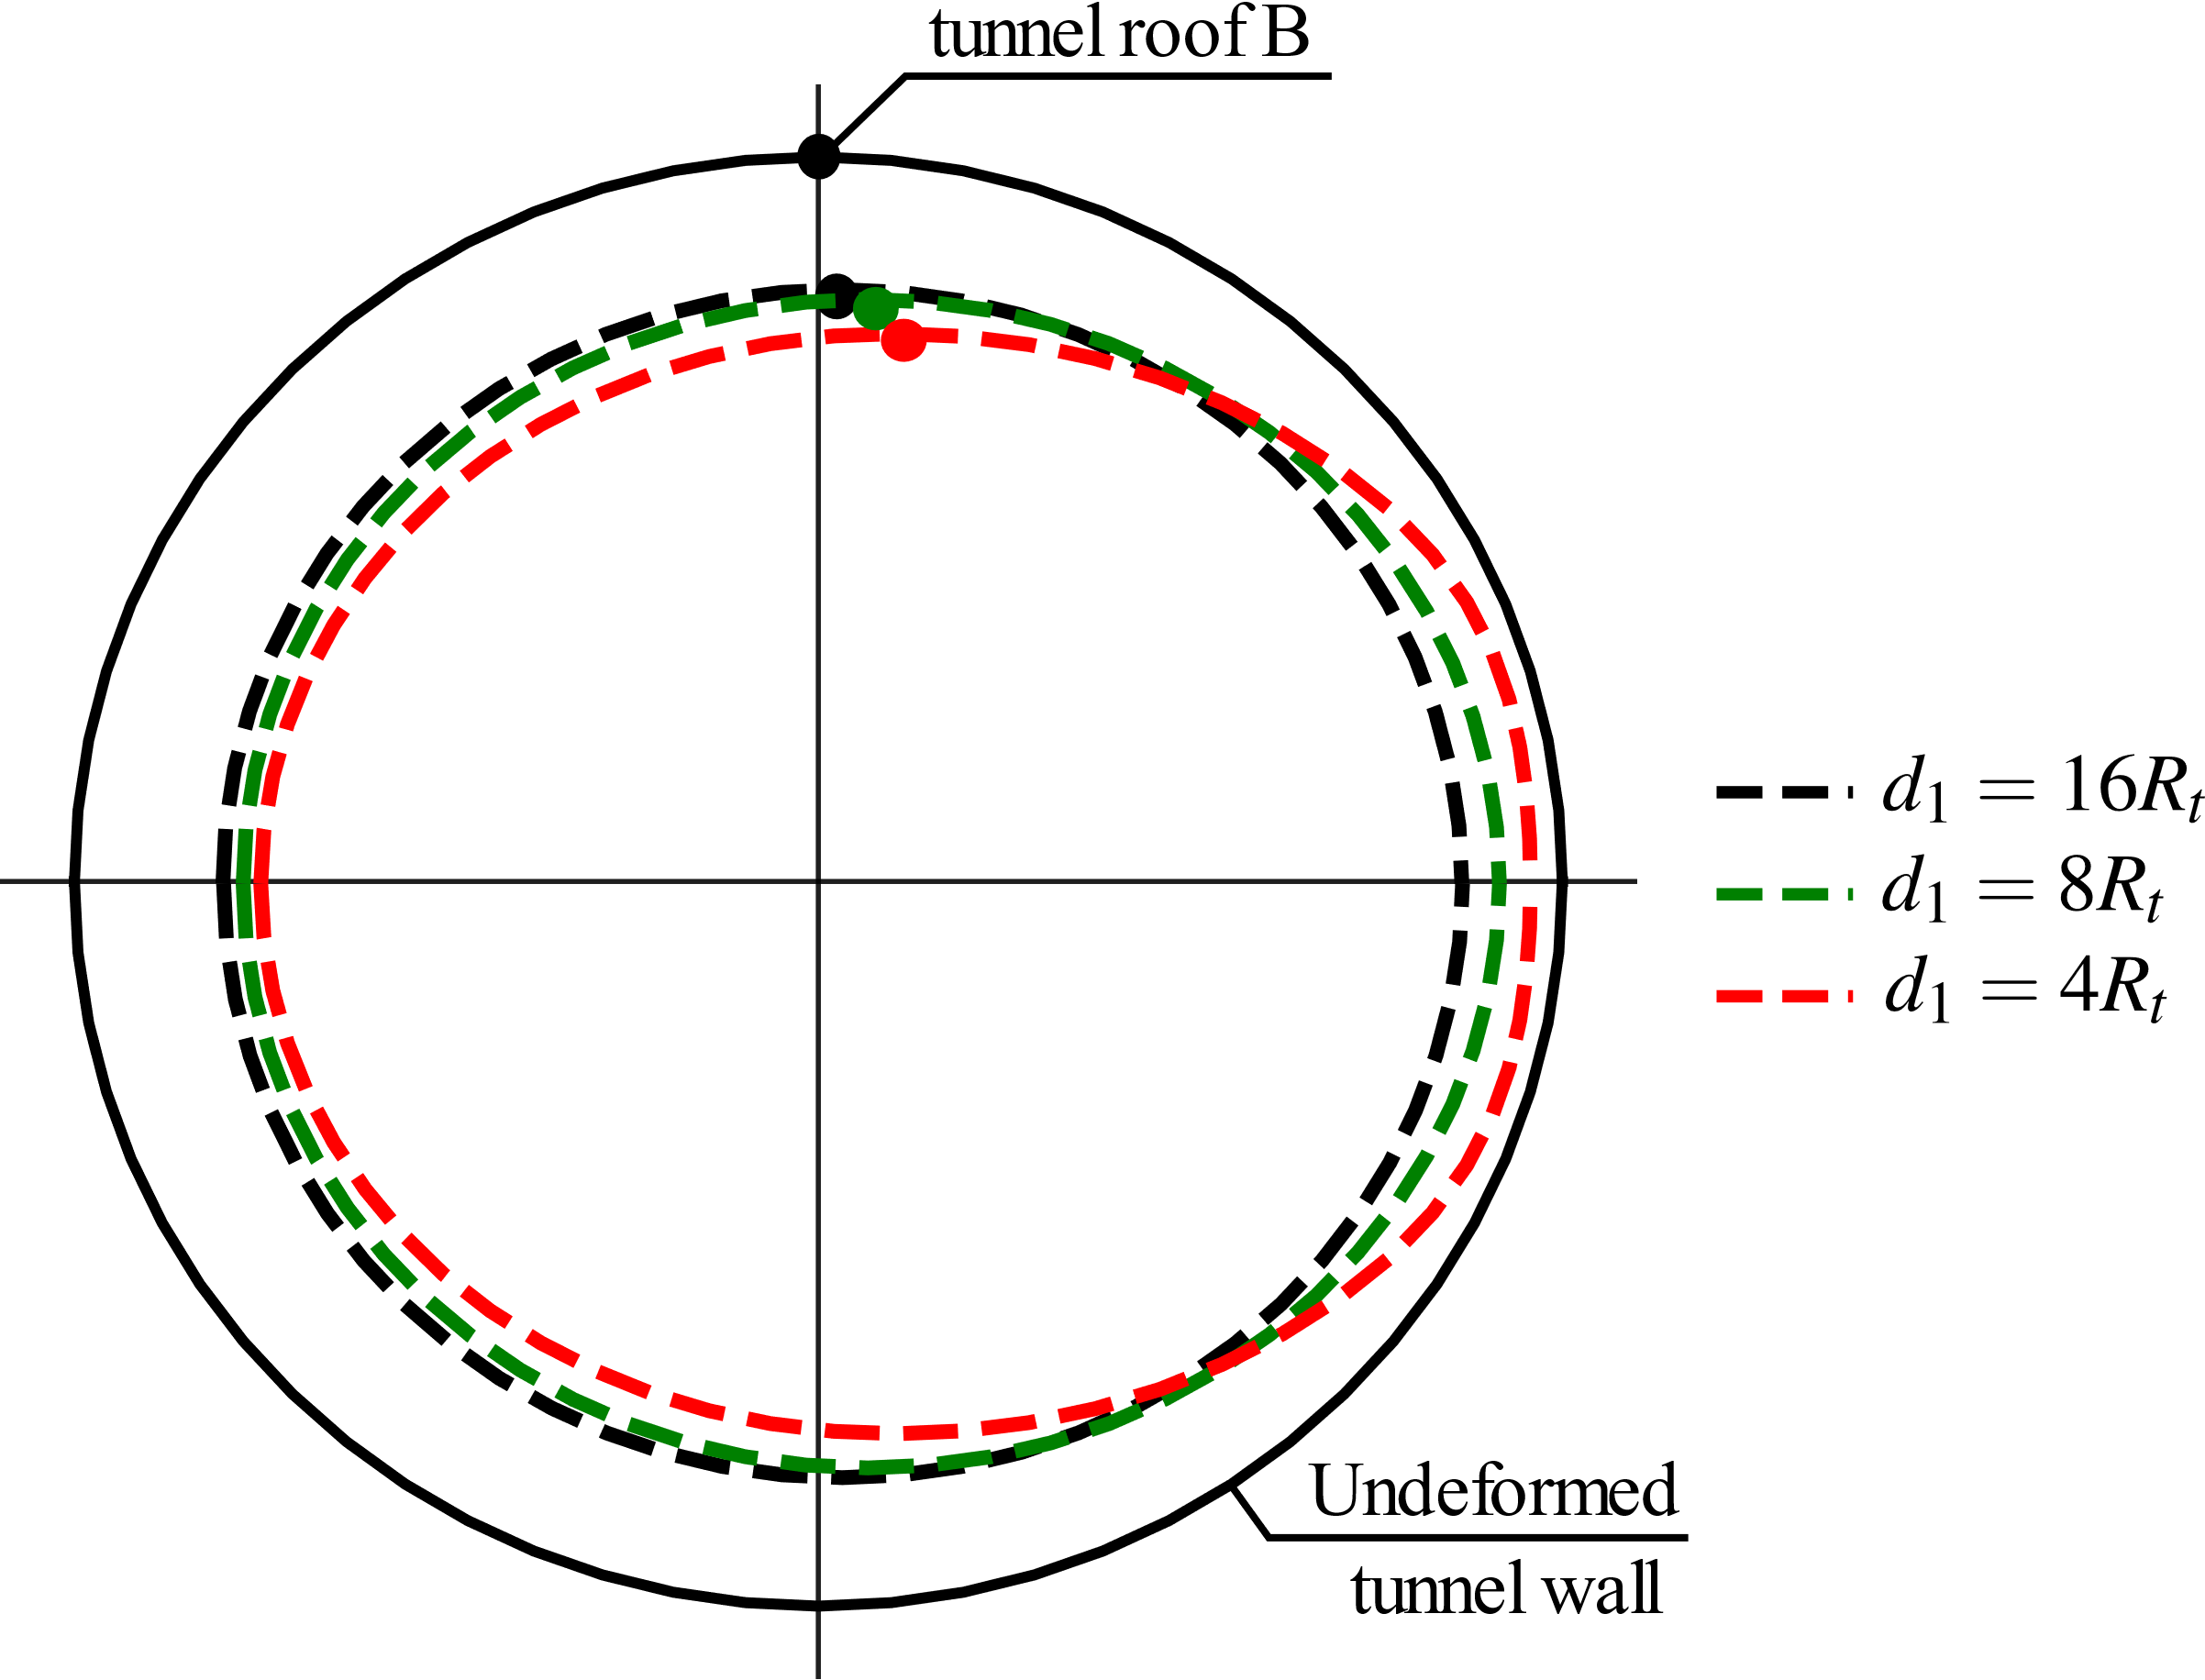

Figure 21: Illustration of the deformation anisotropy induced by twin tunnels proximity.

The second feature of the tunnel deformation that deserves to be mentioned refer the specific deformation patterns prevailing in the region surrounding the tunnel wall. In consistence with experimental data, the plastic cohesion $c$ and viscoplastic cohesion $c_{vp}$ reported in Table 2 comply with condition $c$ > $c_{vp}$. This notably implies that irreversible viscoplastic strains will be activated earlier as the tunnel excavation. Schematic representation of deformation patterns within the rock mass is illustrated in Fig. 22.

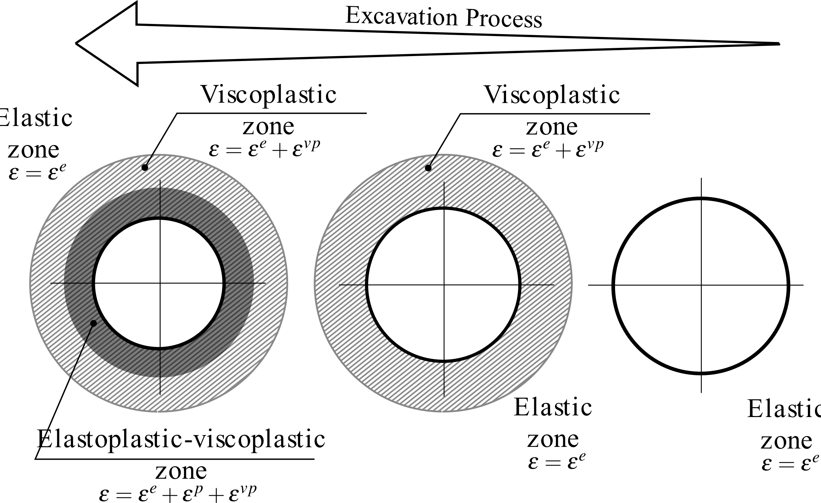

Figure 22: Evolution of deformation zones as the tunnel excavation proceeds.

## 7.2 Short and long-term convergence profiles

Figs. 23, 24, and 25 show the convergence profiles in the twin tunnels with gallery (WG) considering the different constitutive models of the rock mass (E - blue, EP - yellow, VP - magenta, EPVP - red and green) and of the lining (EL and VEL). The interaction effect rising from twin tunnels proximity is investigated by considering three values $d_{1}=4R_{t}$, $d_{1}=8R_{t}$, and $d_{1}=16R_{t}$. The solid lines refer to short-term analysis (ST) whereas the dashed lines to long-term analysis (LT).

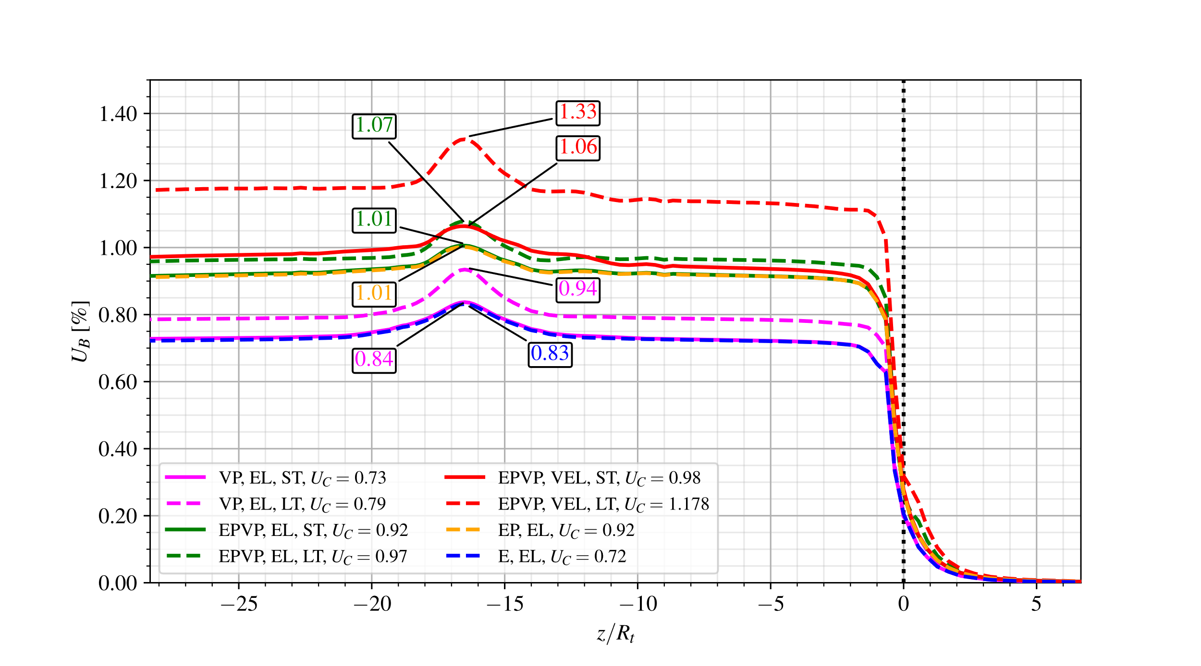

Figure 23: Convergence profiles: short-term (ST) and long-term (LT) analyses for the configuration with gallery (WG) and distance between twin tunnels $d_{1}=16R_{t}$.

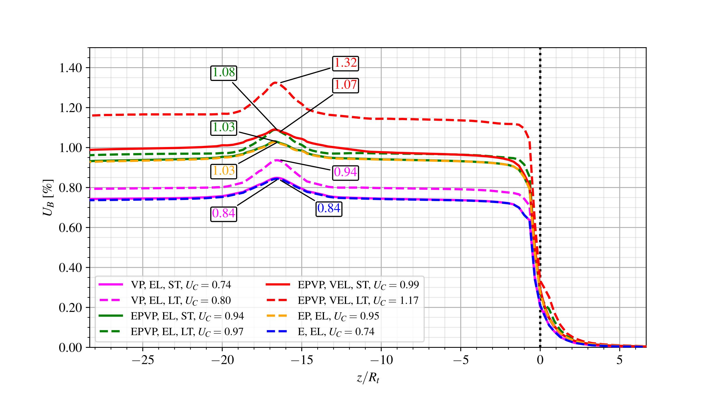

Figure 24: Convergence profiles: short-term (ST) and long-term (LT) analyses for the configuration with gallery (WG) and distance between twin tunnels $d_{1}=8R_{t}.$

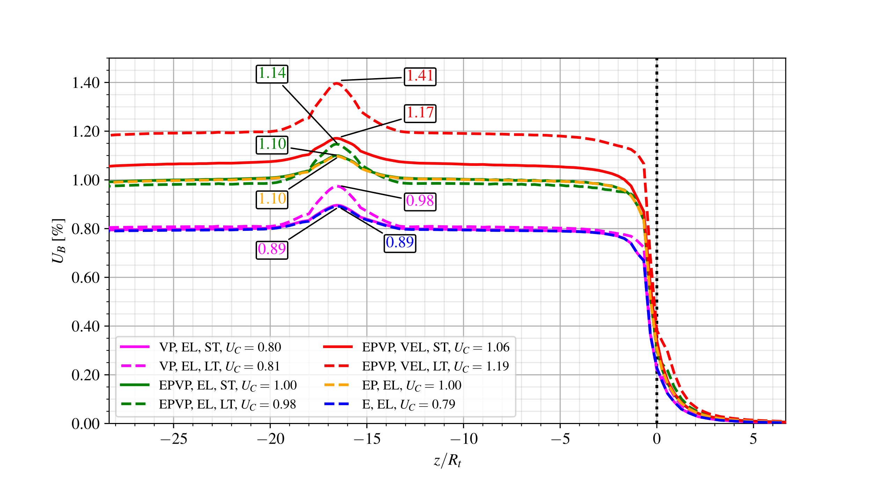

Figure 25: Convergence Profiles: short-term (ST) and long-term (LT) analyses for the configuration with gallery (WG) and distance between twin tunnels $d_{1}=4R_{t}$.

For all investigated values of twin tunnels distance $d_{1}$, the convergence profiles obtained in short-term (ST) analyses are very similar for both the E-EL (blue dashed line) and the VP-EL (magenta solid line) constitutive model configurations. This mainly attributed to relatively high value considered for the tunnel/gallery advancement rate and lining installation (excavation speed ), thus limiting the viscous effects on the tunnel deformation. The same explanation holds regarding the results derived from the short-term (ST) analyses with the EP-EL (yellow dashed line) or EPVP-EL (green solid line) constitutive model configurations. However, the viscous effects give rise to delayed tunnel deformation progressively affecting the long-term (LT) convergence (dashed green line) at the tunnel roof B. The discrepancy between short-term and long-term responses is more pronounced when a time-dependent viscoelastic lining is considered, as clearly indicated from the convergence associated with the EPVP-VEL model (solid and dashed red lines).

It is noted that the relatively high stiffness considered of the elastic lining is likely to significantly reduces the viscous component of tunnel wall deformation. This can be illustrated by analyzing the short-term and long-term convergences for VP-EL model (solid and dashed magenta line). In this configuration, the twin tunnels proximity induces a substantial increase in the short-term (ST) prediction of $U_{C}$ when comparing $d_{1}=8R_{t}$ and $d_{1}=4R_{t}$, whereas the long-term (LT) convergence hardly changes mainly due to the restriction imposed by the stiff lining.

Referring to the configuration analyzed in Figs. 23, 24, and 25, the ovalization effect may be illustrated by visualizing in Fig. 26 the anisotropic deformation of a tunnel cross-section located far behind the face in the particular case of twin tunnel distance $d_{1}=4R_{t}$. In this figure, the configuration of a single circular tunnel ($d_{1}→∞$) is also shown as a reference case.

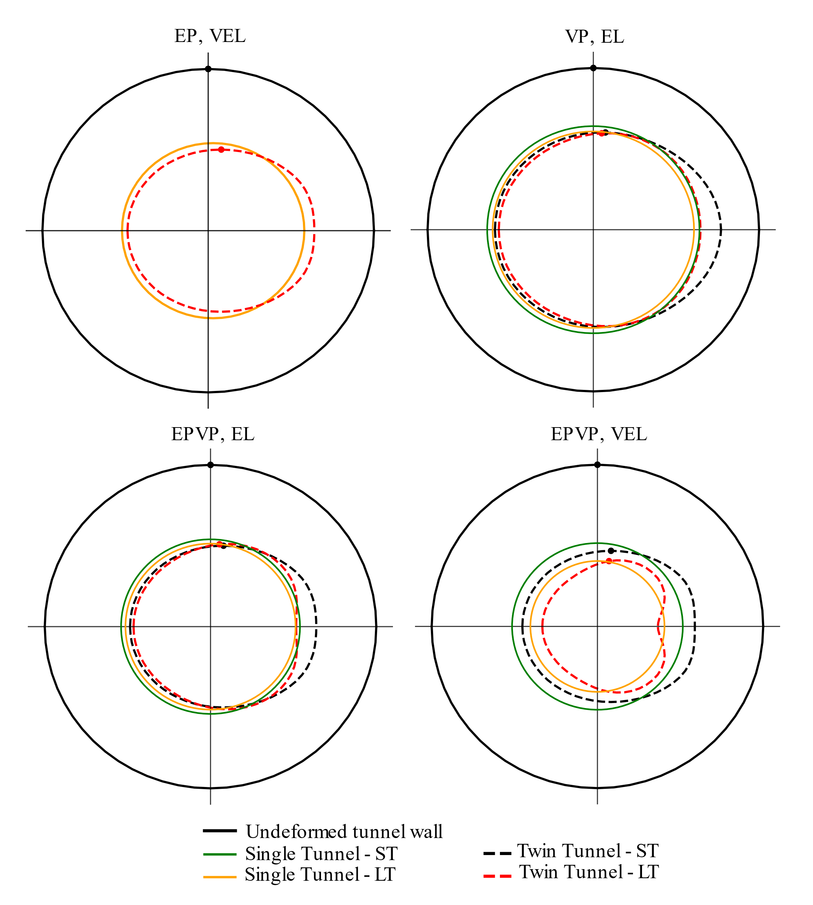

Figure 26: Illustration of deformation anisotropy induced: configuration with gallery (WG) and distance between twin tunnels $d_{1}=4R_{t}.$

In that respect, Fig. 27 provides further illustration of the ovalization effect by plotting the anisotropy ratio $U_{B}/U_{A}=u_{y}\left(B\right)/u_{x}\left(A\right)$ between the vertical displacement $u_{y}$ at the roof B and the horizontal displacement $u_{x}$ at the side wall $A\left(x=R_{t}{-d}_{1}/2,y=R_{t},z\right)$. The resulted presented in this figure correspond to twin tunnels without transverse gallery (NG) and distance $d_{1}=4R_{t}$. The results suggest a more pronounced ovalization effect short-term tunnel deformation (solid lines).

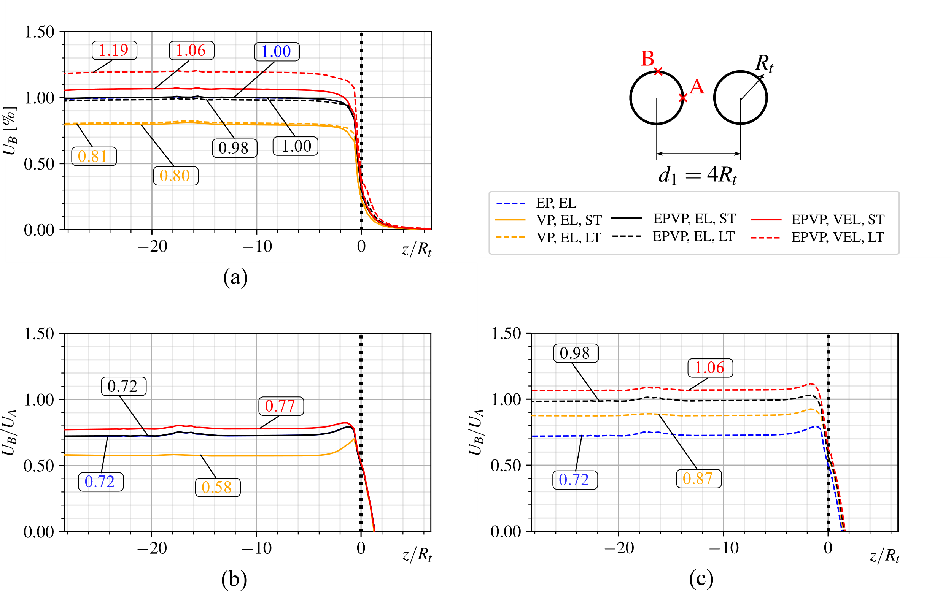

Figure 27: Deformation anisotropy induced by twin tunnels proximity for the configuration without gallery (NG) and distance between twin tunnels $d_{1}=4R_{t}$: (a) convergence profile at the tunnel roof B, (b) anisotropy ratio obtained in short-term analysis, (c) anisotropy ratio obtained in long-term analysis.

## 7.3 Additional numerical analyses: impact of creep deformation

This section provides further numerical results obtained from long-term and short-term analyses, with particular emphasis on the effect of time-dependent behavior of the rock material and lining constituent materials. Fig. 28 displays the long-term convergence profiles for $d_{1}=16R_{t},8R_{t}$ and $4R_{t}$ (yellow, green and red lines, respectively) considering viscous constitutive models: viscoplastic rock mass with elastic lining (VP-EL - solid lines), elastoplastic-viscoplastic rock mass with elastic lining (EPVP-EL - dashed line) and viscoelastic lining (EPVP-VEL - dotted lines). To emphasize the interaction rising from twin tunnels proximity and transverse gallery, the results obtained in the reference configuration of a single tunnel (black lines) are also shown. Close values of the peak convergence $U_{peak}$ are obtained at the tunnel roof for the EPVP-VEL model with $d_{1}=16R_{t}$ (yellow dotted line) and with $d_{1}=8R_{t}$ (green dotted line). This result may be explained by the fact the overall interaction effect on tunnel convergence results from the competing effects of twin tunnel proximity (defined by $d_{1}$) and the time necessary for complete gallery excavation and its intersection with longitudinal tunnel (also defined by length by $d_{1}$). The results indicated that these competing phenomena lead to equivalent overall effect in the cases of $d_{1}=8R_{t}$ and $d_{1}=16R_{t}$. In the case of $d_{1}=4R_{t}$ (red dotted line), the effect of twin tunnel proximity appears to be predominant, which lead to higher value of the peak convergence $U_{peak}$.

Referring to EPVP-VEL and EPVP-EL models (dotted lines and dashed lines), it can be seen from the results of Fig. 28 that higher convergence values are associated with time-dependent behavior of the lining. Unlike the stiff elastic lining, the aging viscoelastic lining induces evolving tunnel convergence along the excavation process.

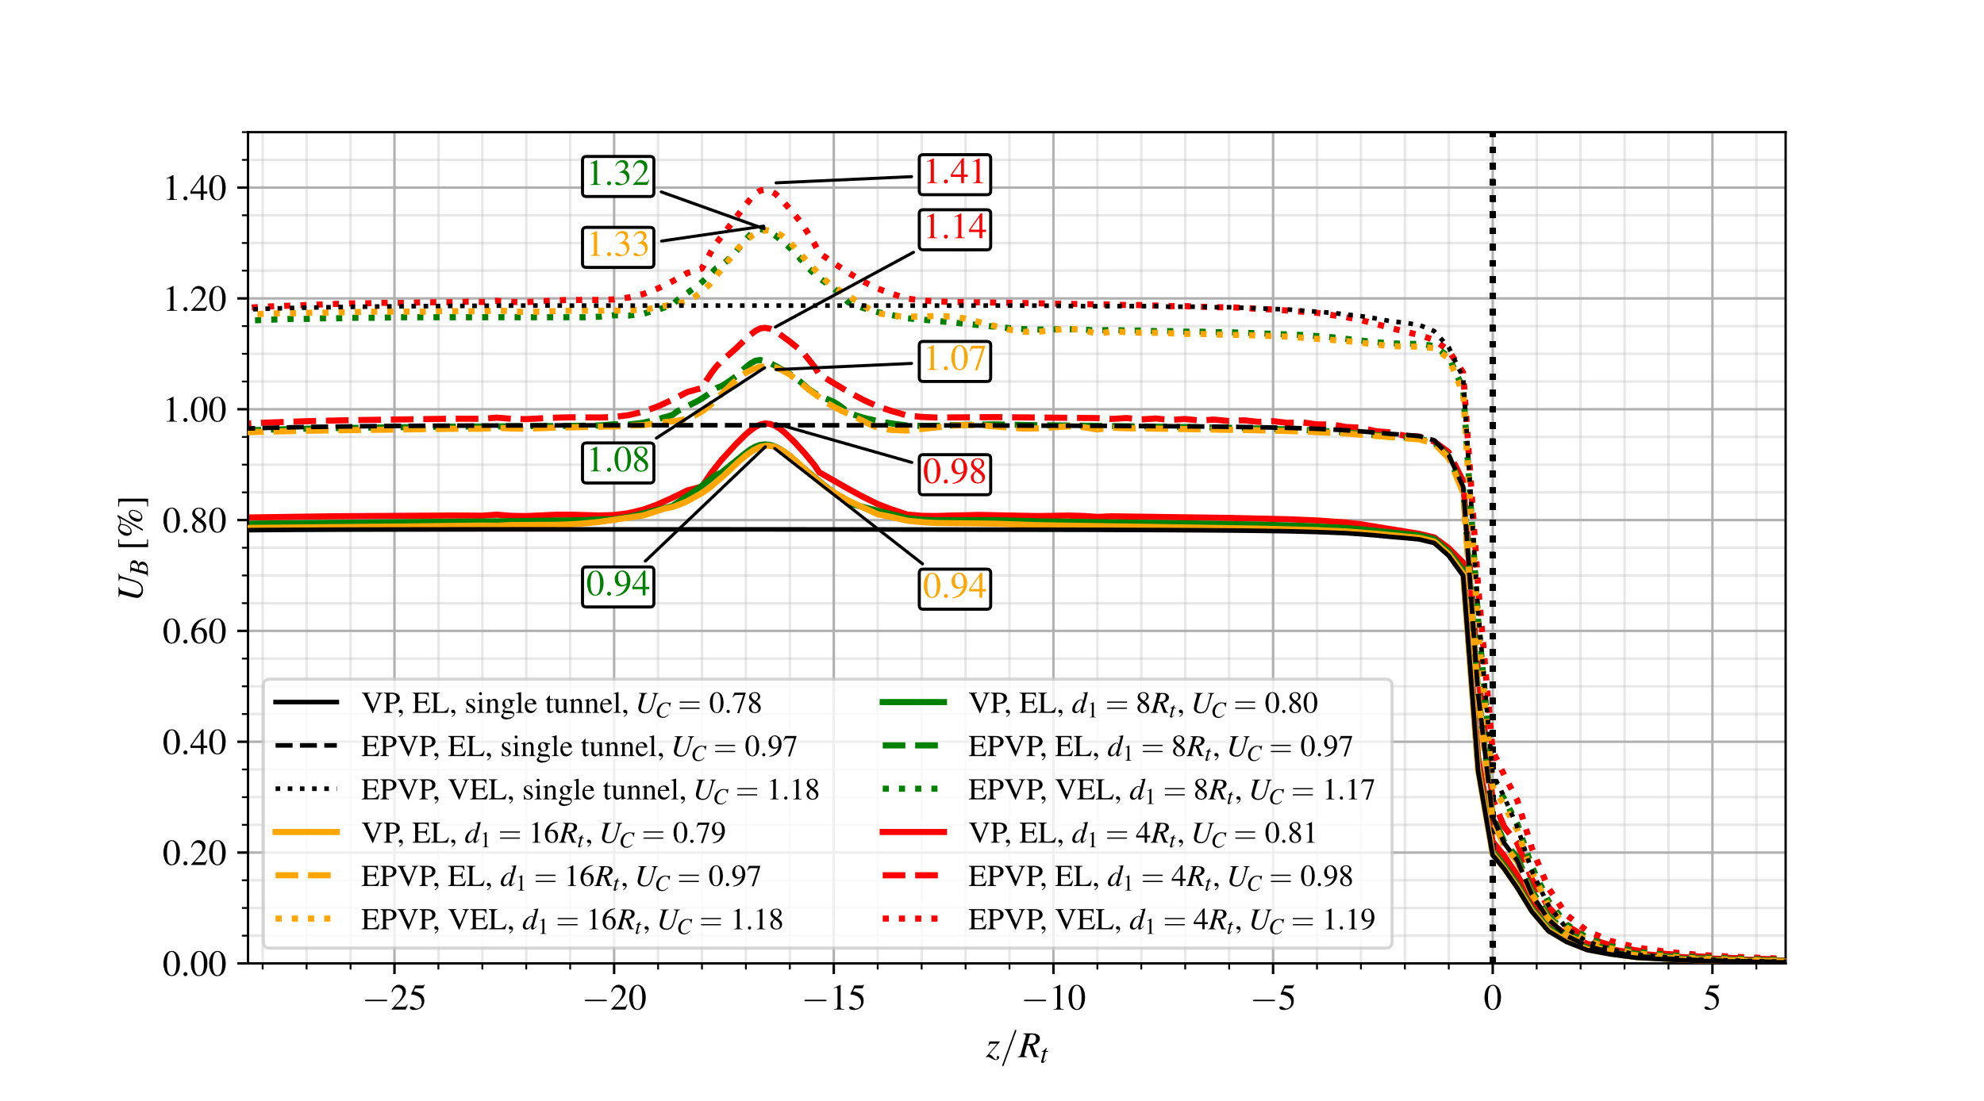

Figure 28: Long-term convergence profiles for the configuration of twin tunnels with transverse gallery (WG): effect of rock mass and lining creep deformation.

The impact of creep deformation on the tunnel convergence can alternatively be illustrated based on the comparison of the numerical predictions obtained in the cases of instantaneous behavior (elastoplastic, elastic) and time-dependent behavior (viscoplastic, viscoelastic) for the constituent materials. Fig. 29 depicts the convergence profiles obtained for $d_{1}=16R_{t},8R_{t}$ and $4R_{t}$ (yellow, green and red lines, respectively) considering the configurations of elastoplastic rock mass with elastic lining (EP-EL - solid lines), elastoplastic-viscoplastic rock mass with viscoelastic lining in short-term analysis (EPVP-VEL-ST - dotted lines) and elastoplastic-viscoplastic rock mass with viscoelastic lining in long-term analysis (EPVP-VEL-LT - dashed lines). The case ofsingle circular tunnel ($d_{1}→∞$) is also analyzed as reference configuration (black lines).

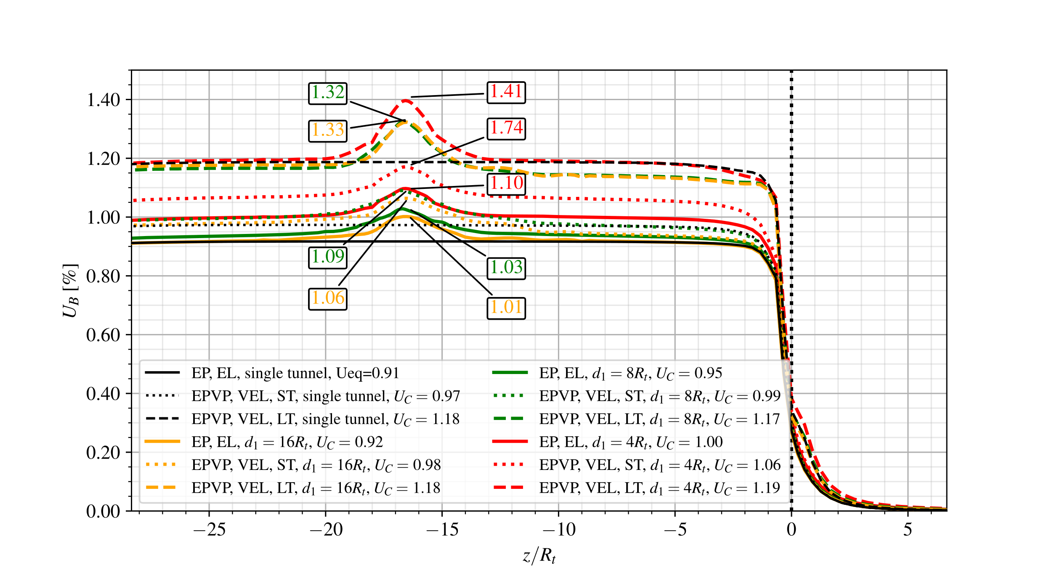

Figure 29: Short-term and long-term convergence profiles obtained for the configuration of twin tunnels with transverse gallery (WG): instantaneous versus delayed behaviors of the rock and lining constituent materials.

Once again, the result predictions shown in this figure emphasize the significative impact of the viscoelastic lining behavior on the short-term convergence profile of the tunnels. At short-term (ST), the elastoplastic-viscoplastic rock mass with viscoelastic lining (EPVP-VEL - dotted lines) leads to higher convergences when compared to the elastoplastic rock mass with elastic lining (EP-EL - solid lines). This is mainly attributed to the fact the early age viscoelastic lining (VEL) exhibits lower relaxation modulus than the stiffness $E_{c_{28}}$ considered for elastic lining (EL), thus resulting in higher tunnel deformation. Regarding the long-term analysis (LT), even though the viscoelastic lining (VEL) (dashed lines) exhibit increasing relaxation modulus due to aging phenomenon, the creep deformation of both the rock and lining constituents result in significantly higher convergences at the tunnel roof when compared to obtained for elastoplastic rock with elastic lining (EP-EL - solid lines). A noticeable increase in the magnitude of $U_{peak}$, induced by the interaction with transverse gallery, is also observed from the short-term response (dotted lines) to the long-term response (dashed lines), highlighting once again the influence of the delayed behavior of the rock and the lining.

## 7.4 Effect of the lining stiffness on the tunnel convergence

In tunnel deformation analyses, the behavior of the concrete lining is classically characterized by the elastic stiffness parameter, which relates the normal stress exerted by the surrounding the rock mass and the normalized lining normal displacement (convergence). The elastic the elastic stiffness parameter is computed from the elastic properties of concrete material and the lining thickness (normalized by the tunnel radius) [38,39]. This concept is extended herein to case of viscoelastic lining by in traducing the instantaneous stiffness modulus at 28 days $K_{c28}$ as:

$$K_{c_{28}}=\frac{E_{c_{28}}}{1+ν_{c}} \frac{1-{\left(1-e_{t}/R_{t}\right)}^{2}}{\left(1-2ν_{c}\right)+{\left(1-e_{t}/R_{t}\right)}^{2}} (12)$$

In the above analyses of sections 7.1, 7.2 and 7.3 the lining thickness were fixed to $e_{t}=e_{g}=0.1R_{t}$, corresponding to lining stiffness $K_{c_{28}}=3400$ MPa. As far as the tunnel deformation is concerned, the latter value characterizes a rather stiff lining, which might be a predominating factor for the control of tunnel convergence.

To assess the effect of the lining stiffness on the convergence profile, a smaller value $e_{t}=e_{g}=0.03R_{t}$, corresponding to lining stiffness modulus $K_{c_{28}}=970$ MPa, will be in the numerical simulations. Referring to the particular case of a rock mass exhibiting elastoplastic behavior (EP), that is only instantaneous behavior, Fig. 30 and Fig. 31 display the convergence profiles at tunnel roof predicted respectively for $d_{1}=16R_{t}$ and $d_{1}=4R_{t}$. Three configurations for the support lining are considered: unlined structure (NL - dashed lines), elastic lining with lower stiffness ($K_{c_{28}}=970$- dotted lines), and elastic lining with higher stiffness ( $K_{c_{28}}=3400$- solid lines). In addition, the numerical simulations include the cases with transverse gallery (WG - blue lines) and without gallery (NG - yellow lines). The reference configuration of a single tunnel is also studied (black lines).

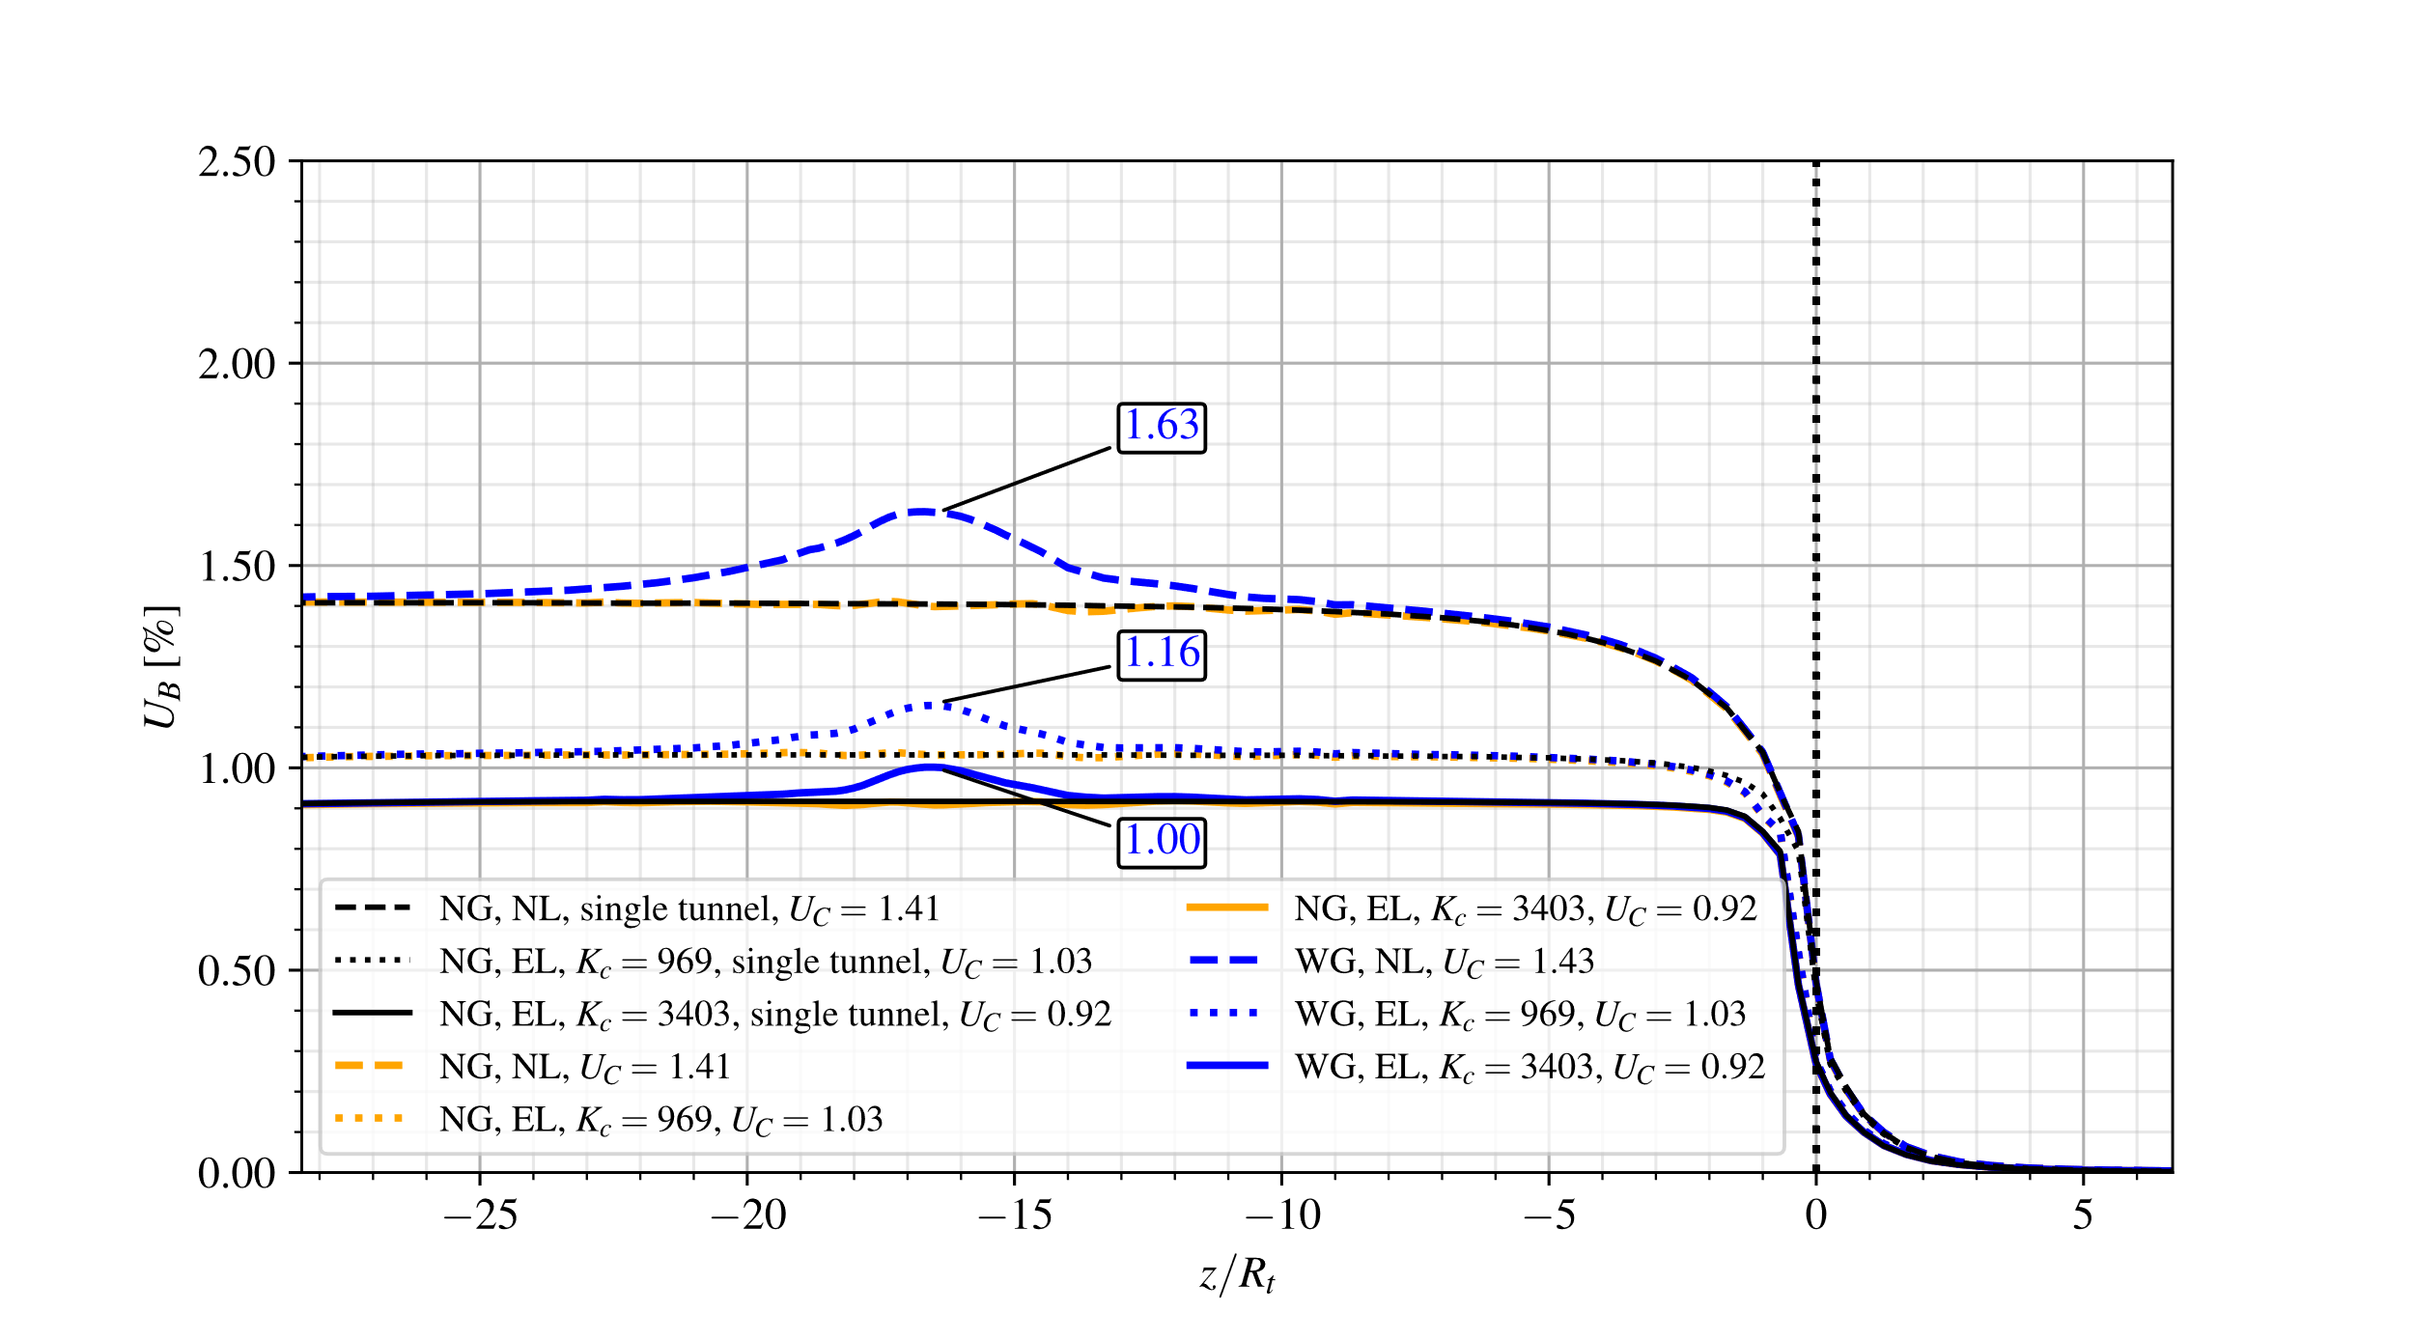

Figure 30: Effect of lining stiffness on the convergence profiles for the configuration of twin tunnels with and without transverse gallery and distance between twin tunnels $d_{1}=16R_{t}$- elastoplastic rock mass, without and with elastic lining $.$

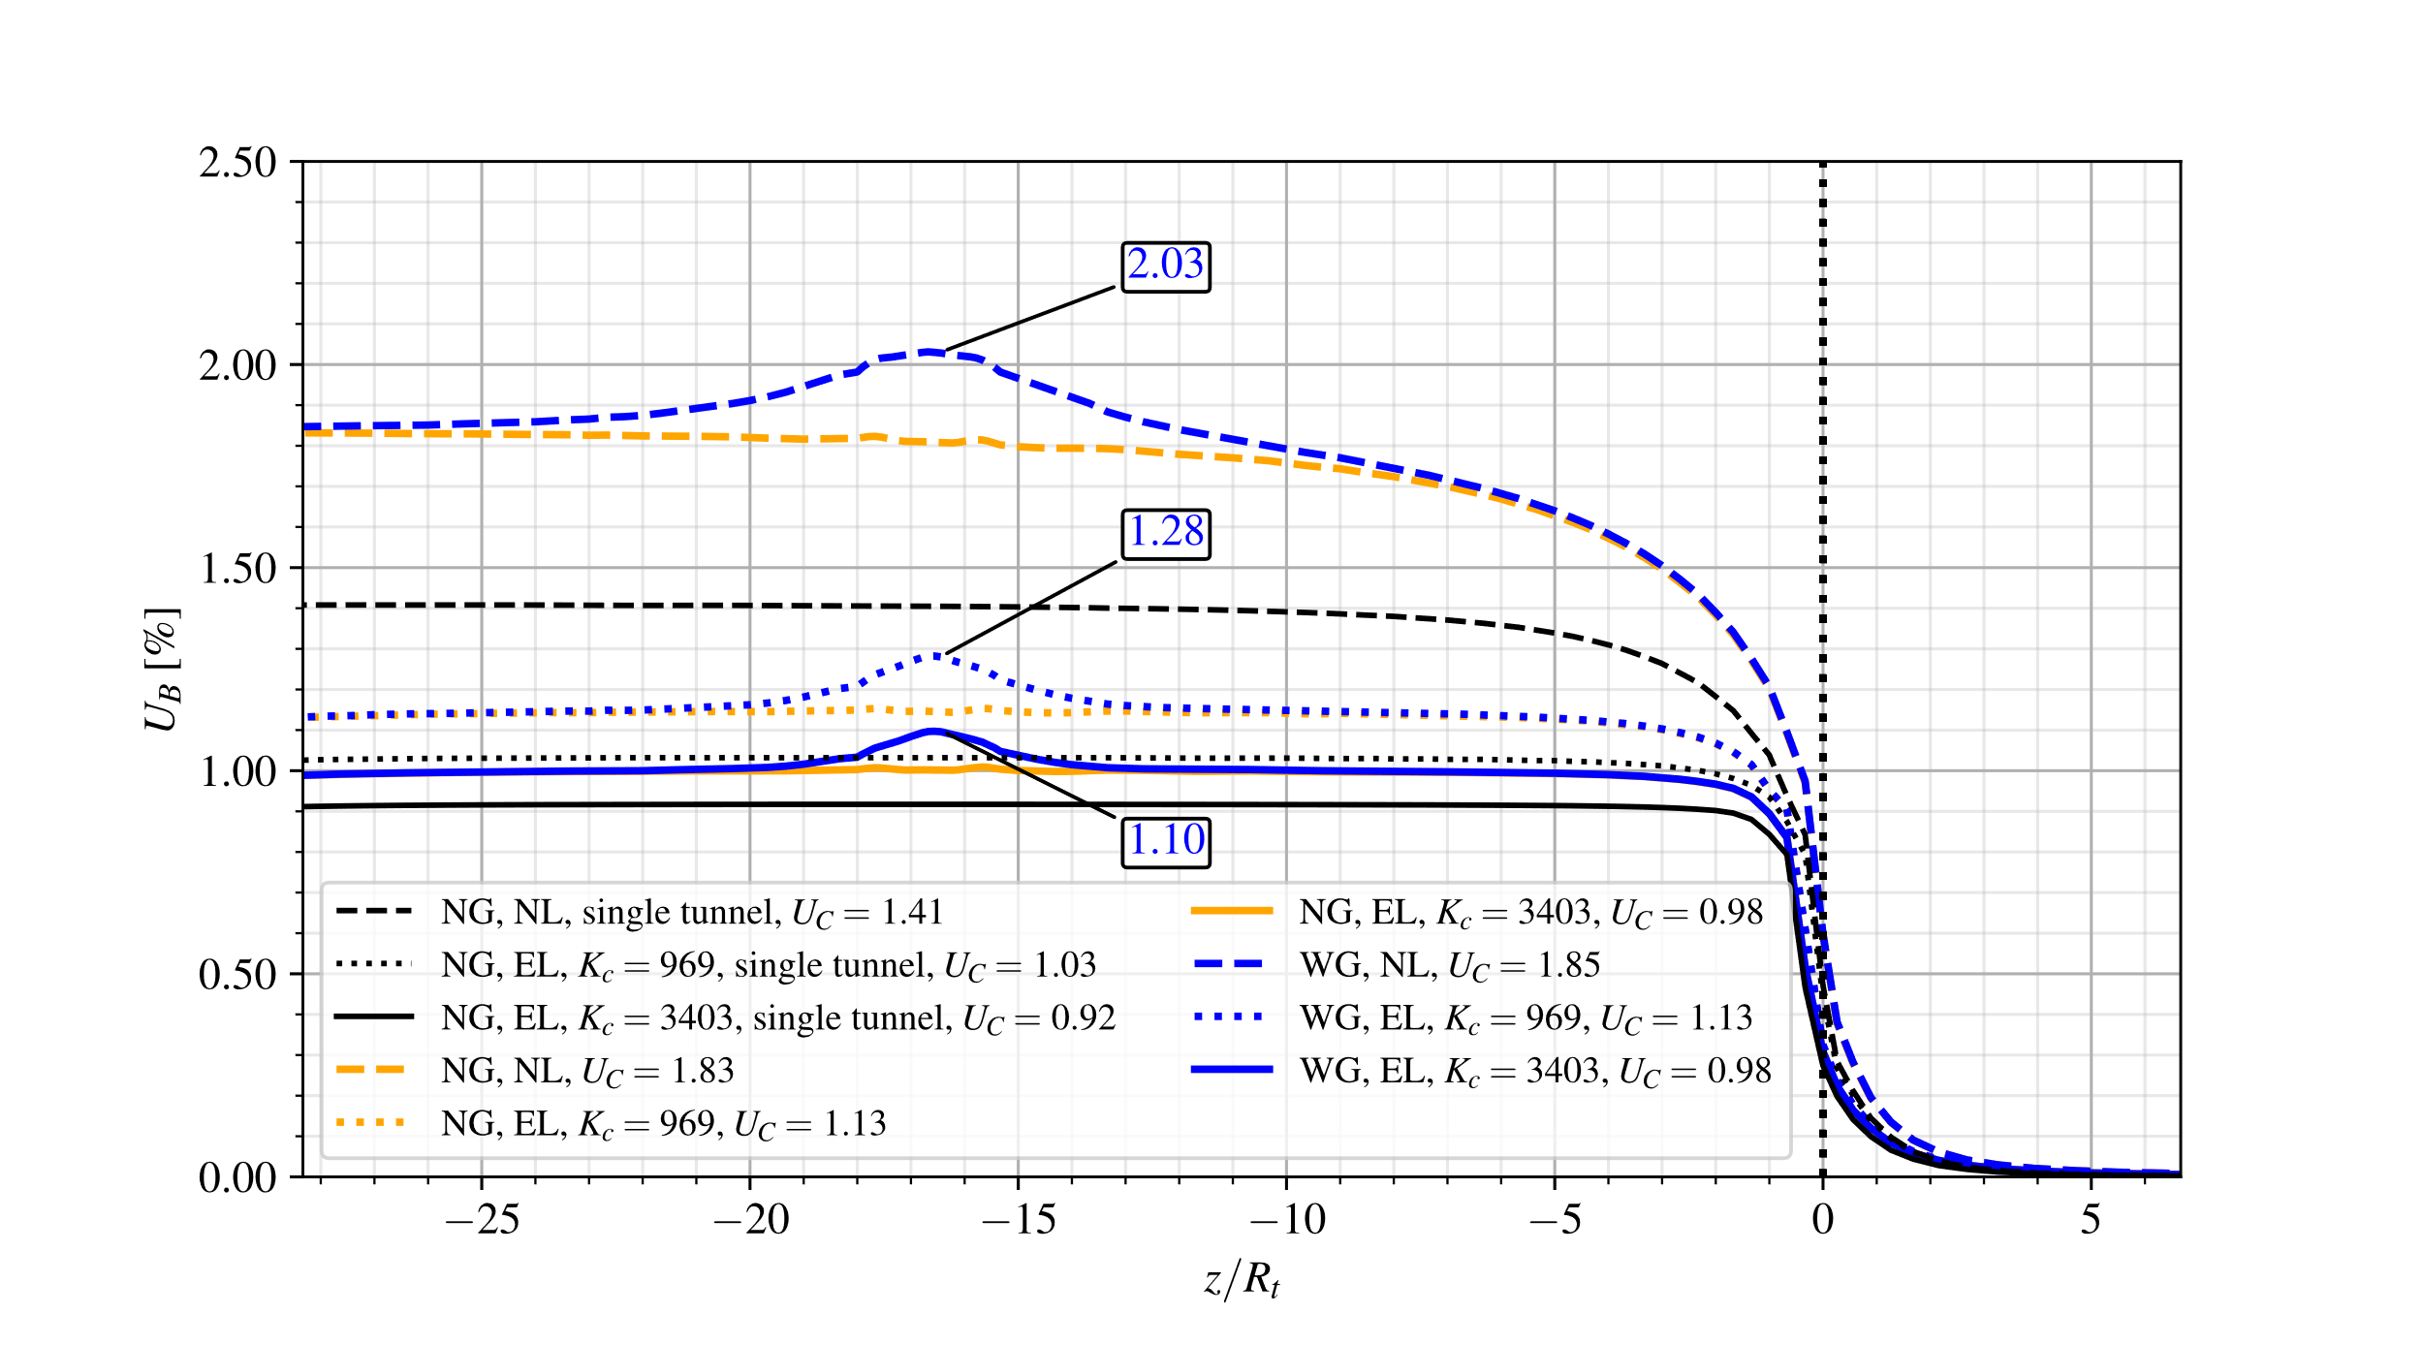

Figure 31: Effect of lining stiffness on the convergence profiles for the configuration of twin tunnels with and without transverse gallery and distance between twin tunnels $d_{1}=4R_{t}$- elastoplastic rock mass, without and with elastic lining $.$

As observed in the simulations of preceding sections, the equilibrium convergence $U_{C}$ far behind the tunnel face is almost unaffected by the presence of transverse gallery.

Regarding first the effect of lining stiffness on the convergence of single tunnel, the stiffer lining (black solid line) leads to a stabilized convergence reduction of approximately 35% with respect to unlined structure (black dashed line), whereas this reduction is only 12% for the moderate stiffness lining (black dotted line).

For twin tunnels with spacing $d_{1}=16R_{t}$, the predictions of stabilized convergence $U_{C}$ (blue and yellow lines) provided in Fig. 30 are close for each lining configuration to those obtained for a single tunnel (black lines). In contrast, the interaction between the twin tunnels reveals significative when the spacing reduces to $d_{1}=4R_{t}$. In that case, the combined impact of lining support and twin tunnels proximity can be assessed by comparing in Fig. 31 the values of convergence $U_{C}$ predicted for $d_{1}=4R_{t}$ (yellow and blue solid lines) and $d_{1}→∞$ (single tunnel - black lines). Compared to the convergence of single tunnel, the increase in convergence induced by twin tunnels proximity reaches values of 30% for unlined structure, 10% for the moderate stiffness lining and 6.5% for the higher stiffness stiff.

Analyzing the effect of lining stiffness on the disturbed region associated along the convergence profile with the presence of transverse gallery, it is first observed that the increase in stiffness reduces in all studied configurations the extent of the disturbed region, whereas the twin tunnels spacing has little impact. For the configuration of spacing $d_{1}=16R_{t}$, where the interaction due to twin tunnels proximity is expected to be minor, the ratio $\frac{U_{peak-U_{C}}}{U_{C}}$ defining the relative variation between peak value and stabilized tunnel roof convergence is about 14% , 12.5% and 8.7% according to the lining stiffness value: $K_{c_{28}}=0$ (unlined), $K_{c_{28}}=970$ MPa and $K_{c_{28}}=3400$ MPa. The values of this ratio are altered to about 9.7%, 13% and 12% for the configuration with spacing $d_{1}=4R_{t}$ in which both effects of lining stiffness and tunnels proximity are simultaneously acting.

In line with the previous analysis investigating the impact of instantaneous stiffness modulus $K_{c_{28}}$ of the lining, Fig. 32 and Fig. 33 present the long-term convergence results in the configurations of elastoplastic-viscoplastic rock mass (EPVP) and viscoelastic lining (VEL) with gallery (WG - blue lines) and without gallery (NG - yellow lines), considering twin tunnels spacing $d_{1}=16R_{t}$ and $4R_{t}$, respectively. The results obtained for the reference single tunnel configuration are also provided (black lines).

Similar to the previous analysis involving constituent materials that exhibit only instantaneous behaviors, the results Fig. 32 indicates indicate that the predictions of stabilized convergence $U_{C}$ in the case of twin tunnels with spacing $d_{1}=16R_{t}$ are very close to obtained for single tunnel.

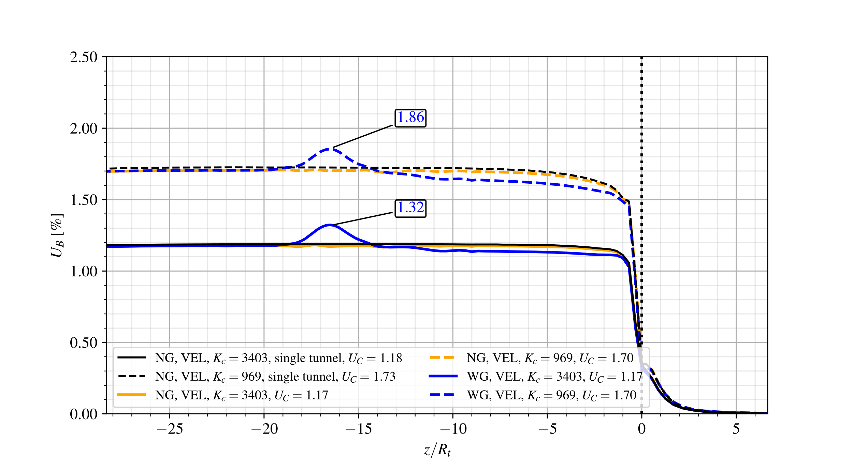

Figure 32: Effect of instantaneous lining stiffness on the long-term convergence profiles for the configuration of twin tunnels with and without transverse gallery and distance between twin tunnels $d_{1}=16R_{t}$- elastoplastic-viscoplastic rock mass, without and with viscoelastic elastic lining $.$

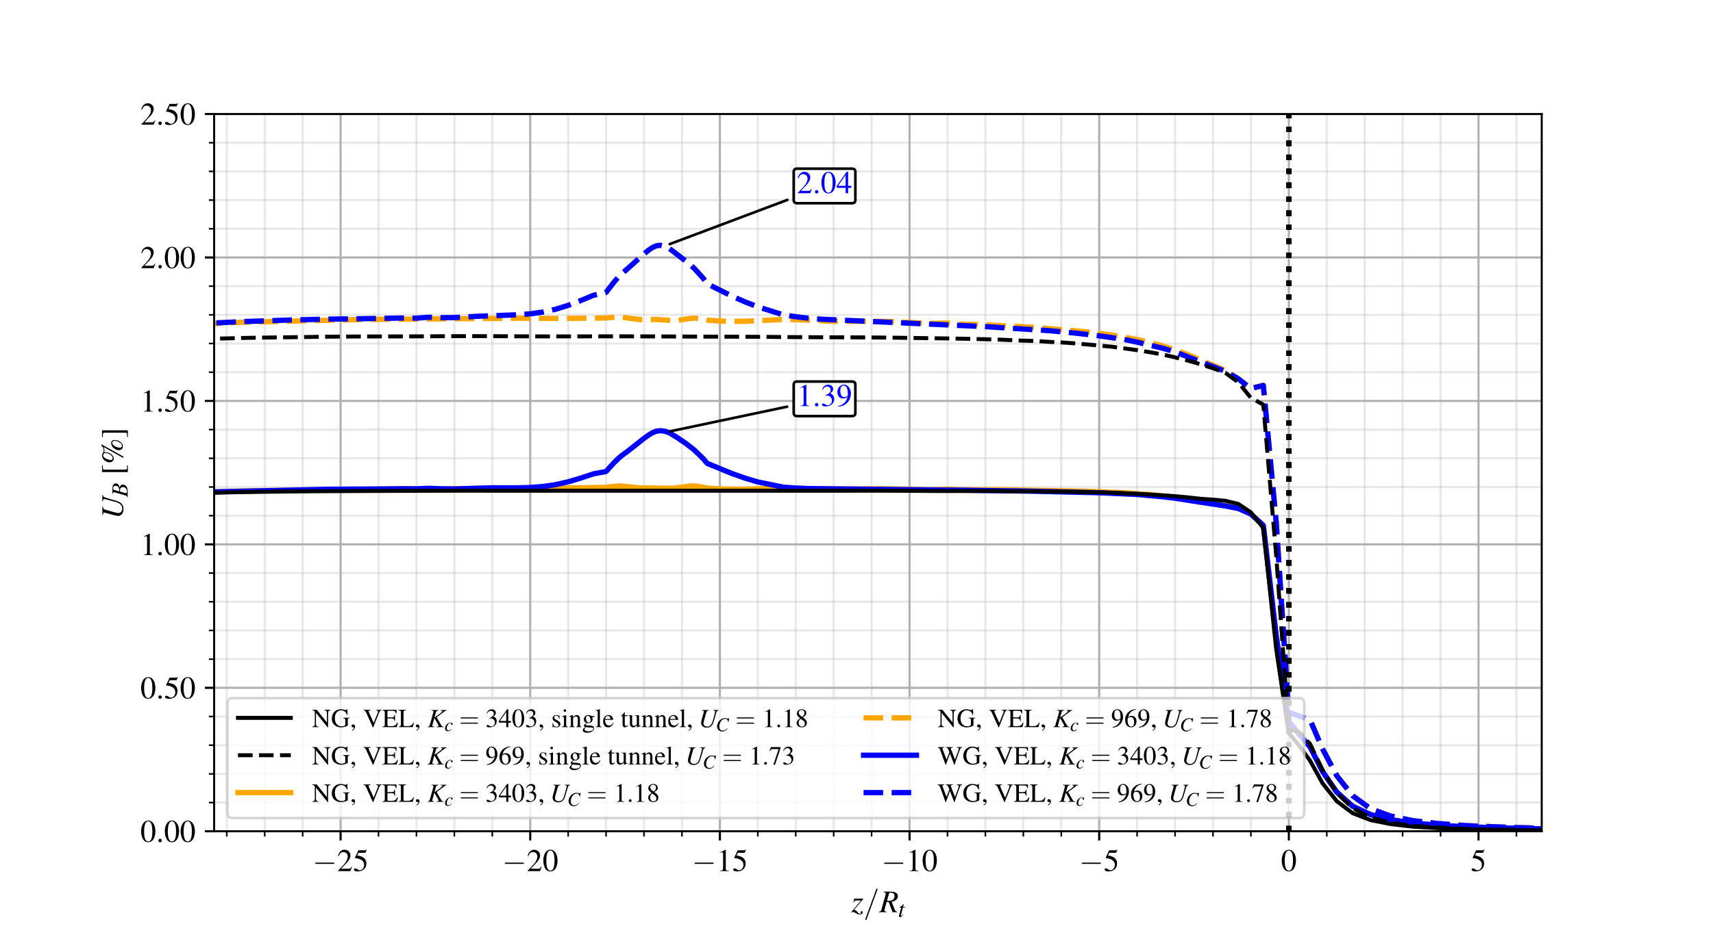

Figure 33: Effect of instantaneous lining stiffness on the long-term convergence profiles for the configuration of twin tunnels with and without transverse gallery and distance between twin tunnels $d_{1}=4R_{t}$- elastoplastic-viscoplastic rock mass, without and with viscoelastic elastic lining $.$

Even in the specific case of $d_{1}=4R_{t}$ where a strong twin tunnels interaction would be expected, the role of lining with higher stiffness on stabilized convergence (blue and yellow solid lines in Fig. 33) is predominating with values close to obtained for single tunnel (black solid line in Fig. 33), thus masking such interaction effect. For lower lining stiffness, the numerical results (blue and yellow dashed lines) indicate a small increase in the value of $U_{C}$ when compared to the single tunnel (black dashed line).

As regards the impact on the peak convergence $U_{peak}$ and extent of the gallery influence zone (disturbed portion of convergence profile), the results show that for each value of twin tunnels spacing $d_{1}$, the latter extent is slightly affected by the instantaneous lining stiffness modulus. In contrast the ratio $U_{peak}/U_{C}$ is significantly affected by the values of $d_{1}$ and $K_{c_{28}}.$ For the configuration with $d_{1}=4R_{t},$ it respectively takes the values $U_{peak}/U_{C}$ = 14.5% and 18

% lower and higher lining stiffness, whereas it respectively takes the values 9.5% and 13% for the configuration with $d_{1}=16R_{t}.$

Finally, the results provided in Fig. 34 and  Fig. 35 refer to configurations defined by time-dependent rock behavior (EPVP) together with instantaneous lining material (EL).

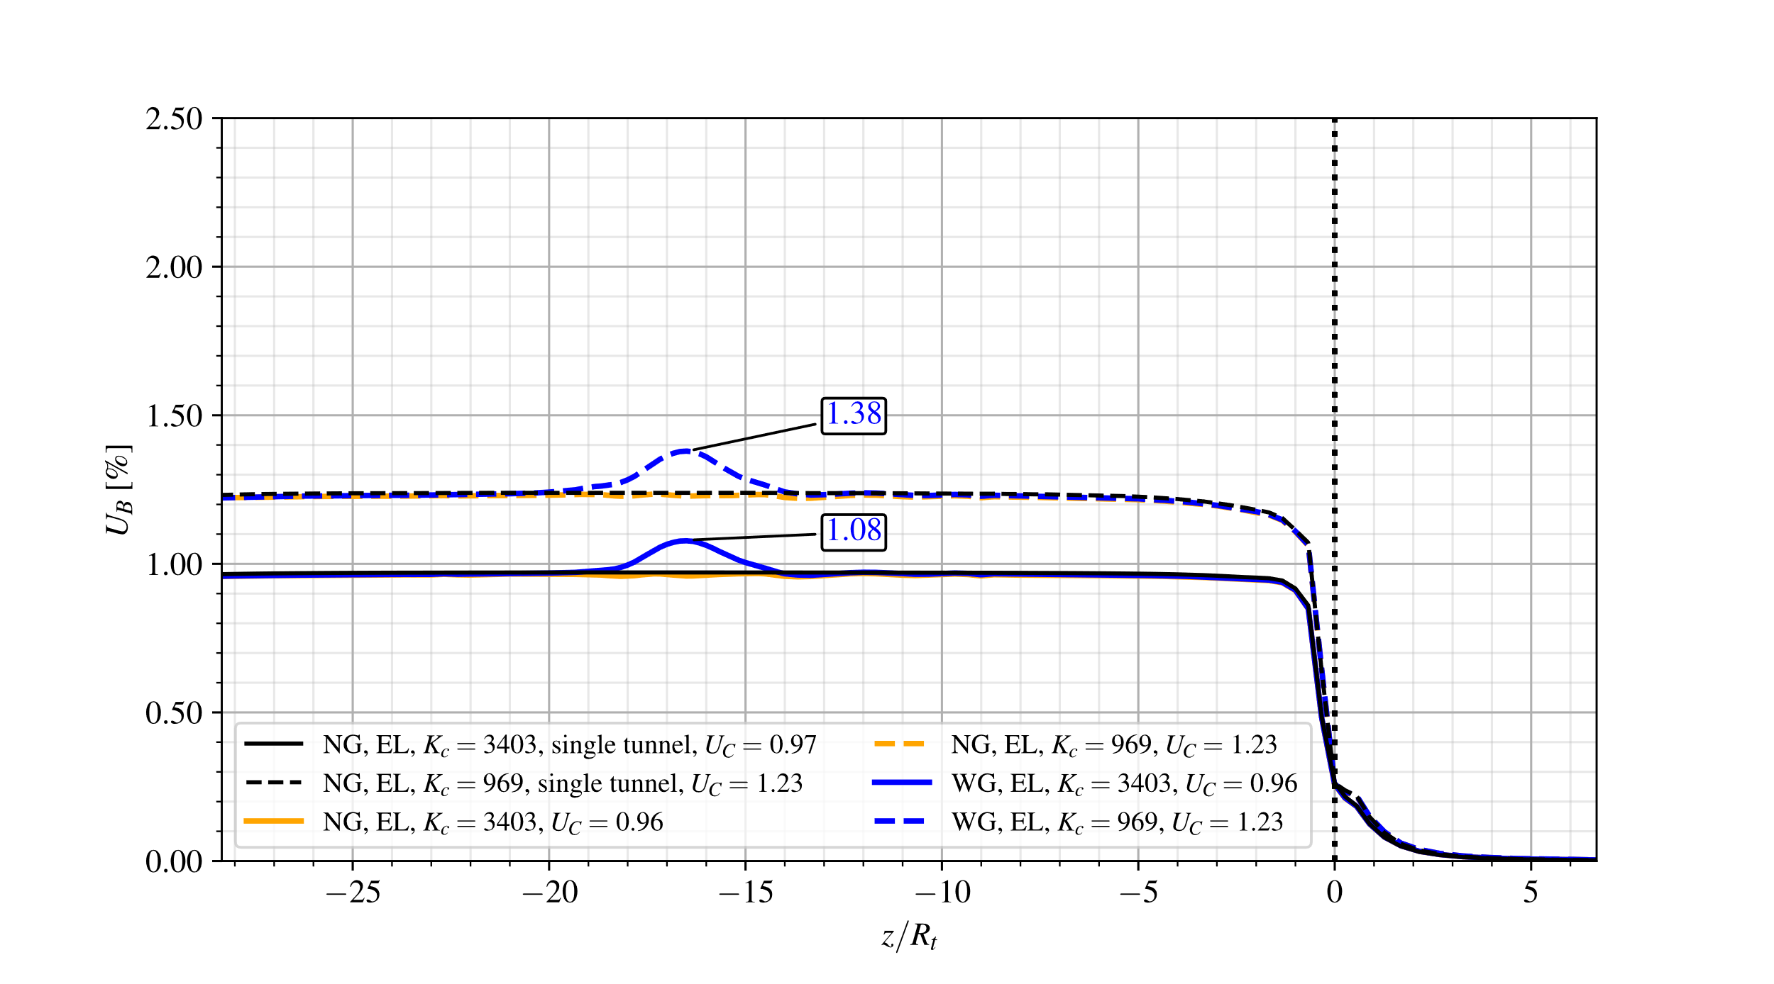

Figure 34: Effect of lining stiffness on the long-term convergence profiles for the configuration of twin tunnels with and without transverse gallery and distance between twin tunnels $d_{1}=16R_{t}$- elastoplastic-viscoplastic rock mass, without and with elastic lining $.$

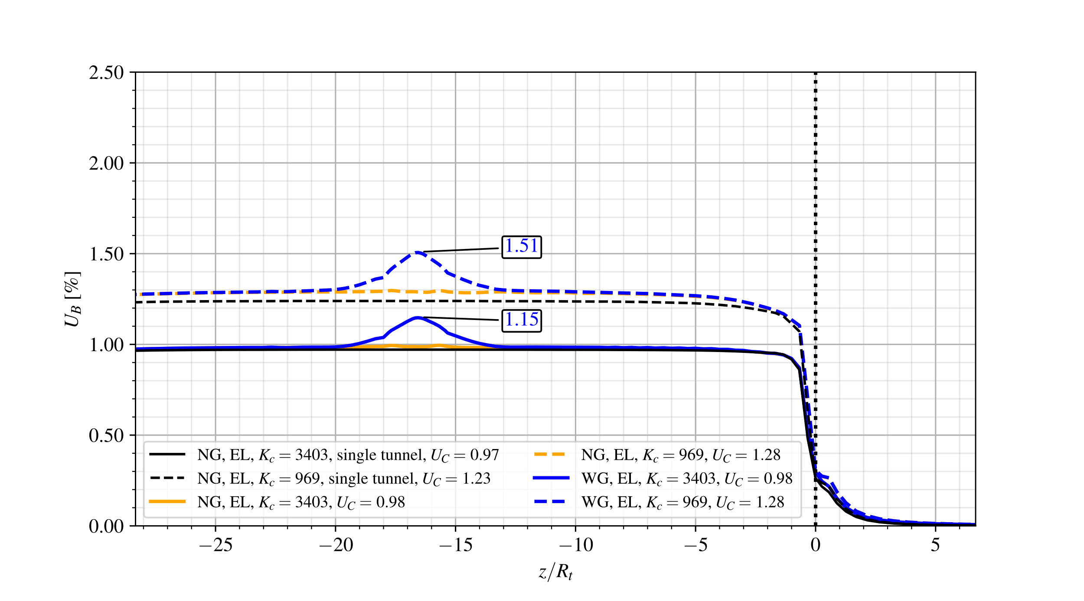

Figure 35: Effect of lining stiffness on the long-term convergence profiles for the configuration of twin tunnels with and without transverse gallery and distance between twin tunnels $d_{1}=4R_{t}$- elastoplastic-viscoplastic rock mass, without and with elastic lining.

Overall, the same observations formulated in the previous analyses regarding the effect of twin tunnel spacing on stabilized convergence still hold: with respect to single tunnel configuration, $U_{C}$ is almost unaffected by the lining stiffness for $U_{C}$ and slightly increased (up to 4%) for $d_{1}=4R_{t}$.

With the elastic lining, the increase in stiffness from $K_{c_{28}}=970$ MPa to $K_{c_{28}}=3400$ MPa leads to a reduction in stabilized convergence $U_{C}$ by 28% for twin tunnels spacing $d_{1}=16R_{t}$ and by 16% for $d_{1}=4R_{t}$, emphasizing once again the strong mechanical interaction between the different components of the tunnel structure.

The peak value of tunnel roof convergence $U_{peak}$ that reflects the coupling associated with intersecting transverse gallery the coupling associated then intersecting is almost unaffected by the lining stiffness, at least for considered data parameters. In that respect, the value of ratio $\frac{U_{peak-U_{C}}}{U_{C}}$ computed in the configuration $d_{1}=16R_{t}$ (resp. $d_{1}=4R_{t}$) is approximately 12% (resp. and 18%) for both values of lining stiffness, which corroborates the predominating effect of tunnels proximity on peak convergence $U_{peak}$.

Additional reference

[39] E. Hoek and E. T. Brown, *Underground Excavations in Rock*, 1st ed. London: E&FN Spon, 1980.